UNIVERSITY OF BUEA
Department of Computer Engineering
CEF 440 Internet and Mobile Programming
App Identity Document
Design and Implementation of a Mobile Application for Car Fault Diagnosis
Group 12 | Supervisor: Dr. Valery Nkemeni | Academic Year: 2025/2026

Introduction
This document defines the complete App Identity of CarDiag, a Car Fault Diagnosis Mobile Application developed by Group 12 as part of the CEF 440 course at the University of Buea. App Identity covers all the elements that define what the application is, how it is recognised by users, and how it is identified by operating systems and distribution platforms.
The document is structured in two main parts. The first part covers the technical identity of the application, including its unique identifiers, platform targets, and versioning scheme. The second part covers the visual identity, including the colour palette, typography, logo, and icon design, all of which establish a consistent and professional look for the application across every screen and platform.

2. Technical Identity
The technical identity groups all the identifiers and configuration values that allow the operating system, the app stores, and the development environment to uniquely recognise the CarDiag application.

2.1 Application Identifiers
Field | Value
Application Name | CarDiag
Full Name | CarDiag Car Fault Diagnosis App
Package Name (Android) | com.group12.cardiag
Bundle ID (iOS) | com.group12.cardiag
App ID | cardiag_group12_cef440
Version Name | 1.0.0
Version Code | 1
Build Type | Debug (Development) / Release (Production)

2.2 Platform Targets
Parameter | Value
Target Platform | Android and iOS (Cross-platform)
Framework | React Native
Target SDK (Android) | Android 13 API Level 33
Minimum SDK (Android) | Android 8.0 API Level 26
Target iOS Version | iOS 14 and above
Minimum iOS Version | iOS 8
Screen Orientation | Portrait (primary), Landscape (optional for reports)
Internet Permission | Required for cloud diagnosis, tutorials, and sync
Bluetooth Permission | Required for OBD-II adapter connectivity
Camera Permission | Required for dashboard warning light scanning
Microphone Permission | Required for engine sound recording

2.3 Versioning Scheme
CarDiag follows Semantic Versioning (SemVer) with the format MAJOR.MINOR.PATCH. The current version is 1.0.0, representing the initial release. The version code increments by 1 with each build submitted to the store. The version name is displayed to the user in the About screen of the application, while the version code is used internally by the Play Store and App Store to manage updates.

2.4 Signing Configuration
All builds of CarDiag are signed using a keystore file to guarantee authenticity and integrity. The debug keystore is generated automatically by Android Studio for development testing. The release keystore is a custom file generated by the development team and stored securely. It must never be committed to version control. Loss of the release keystore makes it impossible to publish updates under the same package name on the Play Store.

3. Visual Identity
The visual identity defines how CarDiag looks and feels across every screen, icon, document, and marketing surface. It ensures that users immediately recognise the application and that the interface communicates trust, technical competence, and clarity.

3.1 Colour Palette
The CarDiag colour palette is built around three core colours. Electric Blue is the primary brand colour, conveying technology and reliability. Black and deep navy provide the dark background that gives the application a professional, high-tech look inspired by real-world OBD diagnostic tools. Warning Orange is used exclusively for alerts, fault indicators, and critical status elements, creating an immediate visual link between the colour and the concept of a vehicle fault.

Swatch | Name | Hex Code | Usage
 | Electric Blue (Primary) | #1E88E5 | Buttons, links, active states, brand elements
 | Deep Navy (Background) | #0A1628 | App background, icon background
 | Carbon Black | #070E1C | Card backgrounds, secondary surfaces
 | Warning Orange (Accent) | #FF6D00 | Fault alerts, warning indicators, needle
 | Light Blue | #42A5F5 | Highlights, secondary interactive elements
 | White | #FFFFFF | Primary text on dark backgrounds
 | Light Grey | #90CAF9 | Secondary text, subtitles, captions
 | Error Red | #D32F2F | Critical error states only

3.2 Typography
CarDiag uses two typefaces across the entire application.

Role | Font | Weight / Size | Usage
Display / Heading | Inter | Bold 700, 24 to 32sp | Screen titles, section headers
Body / UI | Roboto | Regular 400, 14 to 16sp | Body text, labels, buttons, inputs
Caption / Badge | Roboto Mono | Medium 500, 11 to 12sp | Fault codes, version badges, tags

3.3 Logo
The CarDiag logo combines a circular tachymetre instrument with a stylised vehicle silhouette, reflecting the core diagnostic purpose of the application. The tachymetre arc is rendered in Electric Blue on the left half, transitioning to warning orange on the right half, showing the shift from normal operation to a fault state. The orange needle points toward the fault zone. The car silhouette sits at the centre of the instrument, grounding the abstract symbol in automotive context.
The wordmark places Car in white and Diag in Electric Blue, using Inter Bold at a large display size. Below the wordmark, the tagline SMART CAR FAULT DIAGNOSIS is set in Roboto Regular with wide letter-spacing, in a muted light blue. The version badge v1.0.0 appears as a small pill outlined in Warning Orange, positioned below the tagline.
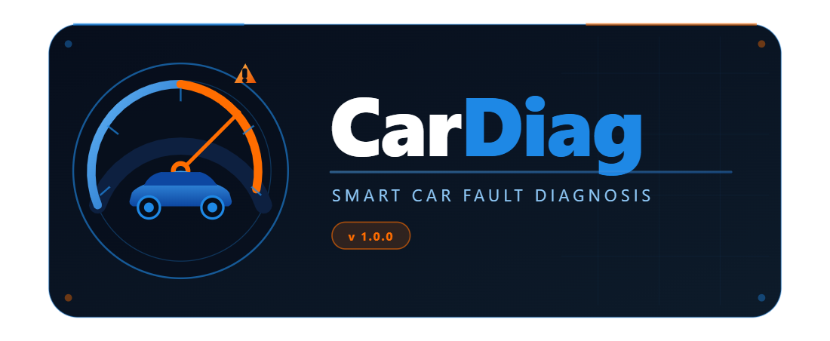

Logo Element | Specification
Symbol | Tachymetre with embedded car silhouette
Symbol Colours | Arc Left: Electric Blue (#1E88E5) / Arc Right: Warning Orange (#FF6D00)
Needle | Warning Orange (#FF6D00), pointing to fault zone
Wordmark | Car (White) + Diag (Electric Blue #1E88E5)
Wordmark Font | Inter Bold, display size
Tagline | SMART CAR FAULT DIAGNOSIS
Tagline Font | Roboto Regular, wide letter-spacing, colour #90CAF9
Background | Deep Navy (#0A1628) with subtle grid overlay
Logo Format | SVG (primary), PNG at 1x / 2x / 3x for raster use
Minimum Width | 200px (below this size, use the icon only)

3.4 App Icon
The app icon is a square version of the logo symbol, sized for use on device home screens, app drawers, and the Play Store or App Store listing. It contains no text, only the tachymetre instrument with the car silhouette, the orange needle, and the warning triangle in the top-right corner.
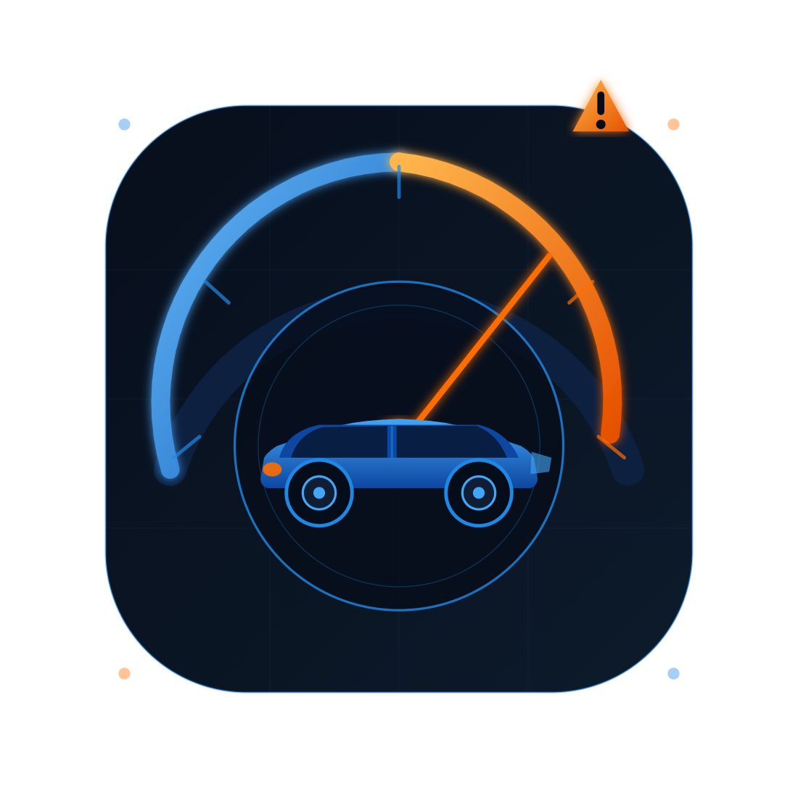

Icon Property | Specification
Shape | Square with rounded corners (radius 24% of width)
Background | Deep Navy gradient (#070E1C to #0D1B2A)
Symbol | Tachymetre + car silhouette + orange needle + warning triangle
Glow Effect | Soft blue glow on arc and needle pivot
No Text | Icon contains no wordmark or tagline
Android Sizes | 48 / 72 / 96 / 144 / 192 dp (mdpi to xxxhdpi)
iOS Sizes | 60 / 76 / 83.5 / 120 / 152 / 167 / 180 / 1024 px
Play Store Icon | 512 x 512 px PNG, no alpha channel
Adaptive Icon | Foreground layer (symbol) + background layer (navy)

3.5 Splash Screen
The splash screen is displayed for approximately two seconds when the application launches. It consists of the full CarDiag logo centred on a Deep Navy background, with a thin Electric Blue animated loading bar at the bottom of the screen. The splash screen serves as the transition between app launch and the Login or Dashboard screen.

Element | Description
Background | Deep Navy (#0A1628), full screen
Content | Full CarDiag logo (symbol + wordmark + tagline)
Position | Centred vertically and horizontally
Loading Indicator | Thin Electric Blue progress bar, bottom of screen
Duration | Approximately 2 seconds, then transitions to Login
Animation | Fade-in on logo, slide-in on progress bar

4. Summary
The table below brings together all the key App Identity values in one place for the development team to use as a reference during implementation.

Identity Element | Value
App Name | CarDiag
Package Name | com.group12.cardiag
Version | 1.0.0 (build 1)
Platforms | Android 8.0 and above / iOS 8 and above
Framework | React Native
Primary Colour | #1E88E5 Electric Blue
Background Colour | #0A1628 Deep Navy
Accent / Warning | #FF6D00 Warning Orange
Primary Font | Inter Bold (headings)
Body Font | Roboto Regular
Code Font | Roboto Mono
Logo | Tachymetre symbol + wordmark + tagline
Icon | Tachymetre symbol only, no text
Tagline | SMART CAR FAULT DIAGNOSIS

